Question 1: Find out the mail servers of the following domain :

Ibm.com

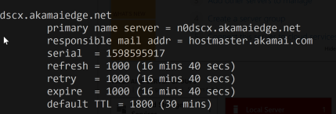

Wipro.com

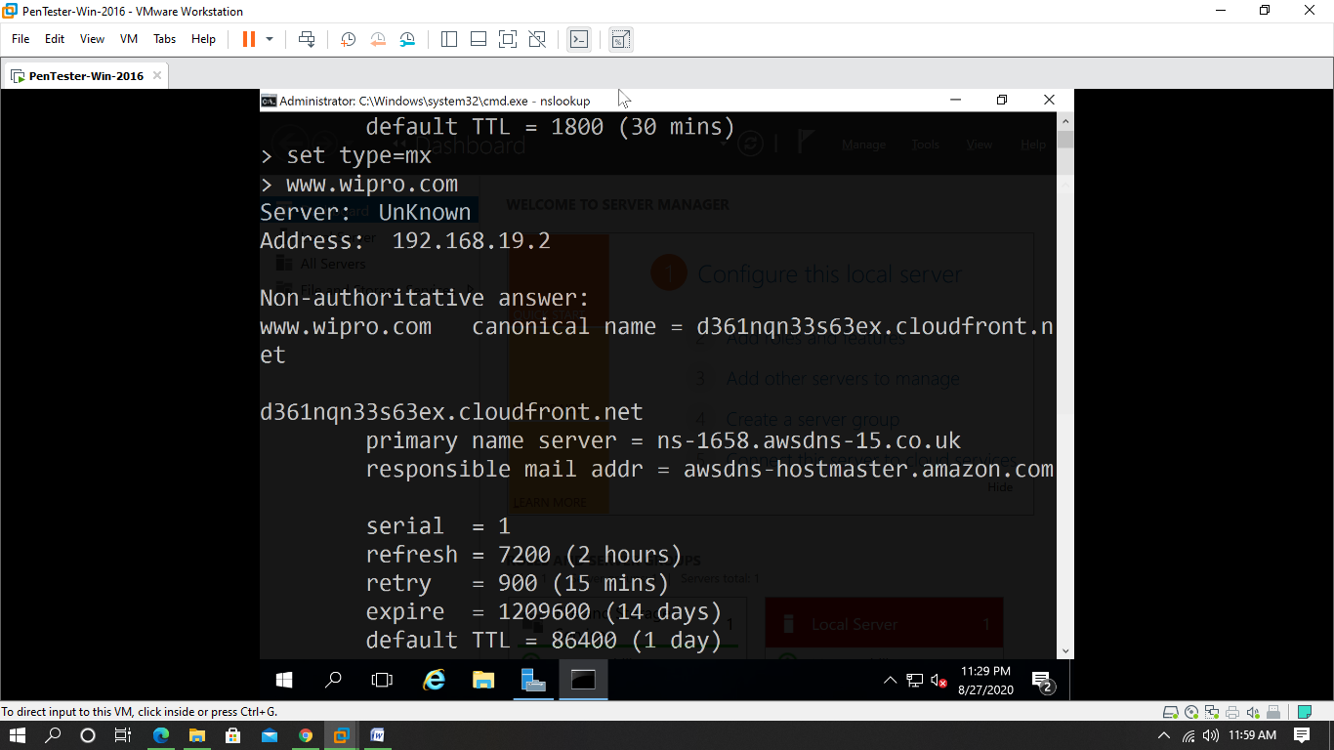

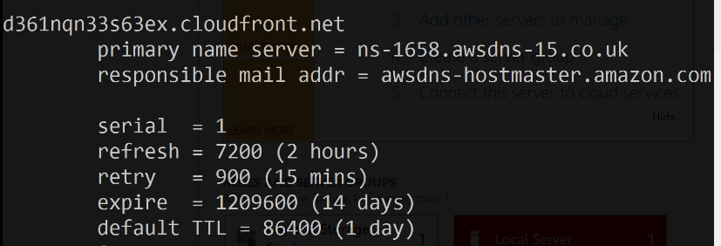

Question 3: Scan and find out port numbers open 203.163.246.23

Port 53 is open

